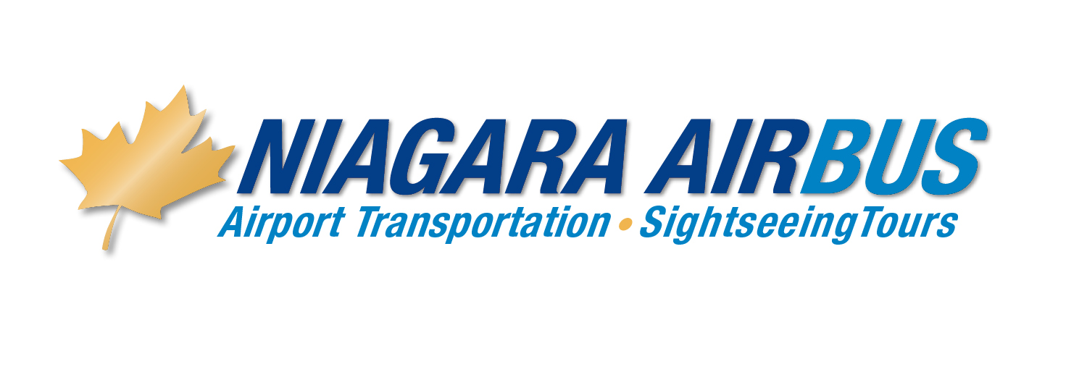

ON LINE BOOKING INSTRUCTIONS

For all On-line AIRPORT reservations, please use the following information:

In your internet browser, simply go to www.niagaraairbus.com

Please have the following ready:
- Dates of travel
- Airline and Flight number information—we require the Airline and flight number of the flight that arrives/departs
- Name of the Hotel you are staying at in Niagara
- Valid Credit card number and expiry date and CVV security code.

In order to receive your special pricing, on the first page, make your choice in the service type called Airport Service Choose “shuttle shared ride” or “ Exclusive” Choose your origin and destination and click on One way or round trip , then enter your conference code assigned specific to your group and click on “book now” . Pricing for this choice will automatically be discounted, based on the code you are using.

The next few screens gather information we require to provide you with the appropriate pickup times etc. The pickup and drop off information pages contain list boxes from which you can simply choose your hotel …. Our system will then fill in the address information.

On the Payment screen, choose to pay for your reservation with a credit card. Simply ensure “credit card” is ticked off, and enter the information.

Please then click (only once) the “Submit” button. It will provide a confirmation number, which you can print as your receipt, or choose to receive an email confirmation of the reservation.

Should anyone require further assistance with the on-line system, they should contact our Support Desk at airsales@niagaraairbus.com or call our reservations agents at 905-374-8111.

Auto Confirmation Procedures

This Function is available 24 hours before Travel Time

Have your confirmation number or Travel Agent Reference Number ready and

Call - 905-374-8111

Immediately enter “0” when you hear the commentary at the beginning.

You will then be prompted to enter your confirmation number - Enter your confirmation

# or Reference Number.

It will then be verified

An automated confirmation will advise you of the date, pickup time, Pickup address and drop off location.

Once done simply press # 1 to verify all is correct or press “0” to stay on the line if you

need to speak with a reservation agent.

